Morning Service of Worship

Welcome and Announcements

Prelude - Prepare Your Hearts for Worship
The prelude is a sacred curtain dropped between the world and our time of corporate worship. During this time, you are encouraged to pray silently, asking the Holy Spirit to enable you to cling to and delight yourself in Jesus Christ.

* Call to Worship – Acts 4:12

* Invocation and Lord’s Prayer (#426)

* Hymn of Praise – #203 “And Can It Be”

Prayer of Confession of Sin
Most holy and merciful Father, we acknowledge and confess before You our sinful nature, prone to evil and slothful in good, and all our shortcomings and offenses. You alone know how often we have sinned, in wandering from Your ways, in wasting Your gifts, in forgetting your love.

O Lord, have mercy upon us who are ashamed and sorry for everything in which we have displeased You. Teach us to hate our errors; cleanse us from our secret faults and forgive our sins, for the sake of Your dear Son. And O most holy and loving Father, help us to live in Your light and walk in Your ways, according to the commandments of Jesus Christ our Lord.

Assurance of Pardon – Psalm 103:8-14

* Response of Praise – Gloria Patri (#622)

* Confession of Faith: Westminster Shorter Catechism
I believe God is a Spirit, infinite, eternal, and unchangeable, in His being, wisdom, power, holiness, justice, goodness, and truth.

I believe there is but one, true, and living God. That there are three persons in the Godhead: the Father, the Son, and the Holy Spirit; and that these Three are one God, the same in substance, equal in power and glory.

I believe that God has foreordained whatsoever comes to pass, and that God made all things of nothing, by the word of His power, in the space of six days, and all very good.

Old Testament Reading – Job 1:1 - 2:10

Our Offering to the Lord

* The Doxology (#624)

* Hymn of Worship – “Through Christ in Me”

Pastoral Prayer

Message from God’s Holy Word

1 Peter 3:18-22

“The Powerful Work of Jesus”

* Hymn of Response – #228 “Rejoice, the Lord is King!”

* Benediction – Numbers 6:24-26

* Postlude – #602 – God be with you till we meet again. By His counsels guide, uphold you; With His sheep securely fold you. God be with you till we meet again.
“Yet Not I, But Through Christ In Me”
(by City Alight)
What gift of grace is Jesus my redeemer
There is no more for heaven now to give
He is my joy, my righteousness, and freedom
My steadfast love, my deep and boundless peace
To this I hold, my hope is only Jesus
For my life is wholly bound to His
Oh how strange and divine, I can sing: all is mine!
Yet not I, but through Christ in me
The night is dark but I am not forsaken
For by my side, the Saviour He will stay
I labour on in weakness and rejoicing
For in my need, His power is displayed
To this I hold, my Shepherd will defend me
Through the deepest valley He will lead
Oh the night has been won, and I shall overcome!
Yet not I, but through Christ in me
No fate I dread, I know I am forgiven
The future sure, the price it has been paid
For Jesus bled and suffered for my pardon
And He was raised to overthrow the grave
To this I hold, my sin has been defeated
Jesus now and ever is my plea
Oh the chains are released, I can sing: I am free!
Yet not I, but through Christ in me
With every breath I long to follow Jesus
For He has said that He will bring me home
And day by day I know He will renew me
Until I stand with joy before the throne
To this I hold, my hope is only Jesus
All the glory evermore to Him
When the race is complete, still my lips shall repeat
Yet not I, but through Christ in me!
CCLI# 21533492
* The congregation is invited to stand
Names of Jesus in the Bible

Advocate (1 John 2:1), Almighty (Rev. 1:8), Alpha and Omega (Rev. 22:13), Amen (Rev. 3:14), Apostle of our Profession (Heb. 3:1), Atoning Sacrifice for our Sins (1 John 2:2), Author of Life (Acts 3:15), Author and Perfecter of our Faith (Heb. 12:2), Author of Salvation (Heb. 2:10), Beginning and End (Rev. 22:13), Blessed and only Ruler (1 Tim. 6:15), Bread of God (John 6:33), Bread of Life (John 6:35), Bright and Morning Star (Rev. 22:16), Capstone (1 Pet. 2:7), Chief Cornerstone (Eph. 2:20), Chief Shepherd (1 Pet. 5:4), Christ (1 John 2:22), Creator (John 1:3), Deliverer (Rom. 11:26), Eternal Life (1 John 1:2), Everlasting Father (Isa. 9:6), Gate (John 10:9), Faithful and True (Rev. 19:11), Faithful Witness (Rev. 1:5), Faithful and True Witness (Rev. 3:14), First and Last (Rev. 22:13), Firstborn From the Dead (Rev. 1:5), God (John 1:1), Good Shepherd (John 10:11), Great Shepherd (Heb. 13:20), Great High Priest (Heb. 4:14), Head of the Church (Eph. 1:22), Heir of all things (Heb. 1:2), High Priest (Heb. 2:17), Holy and True (Rev. 3:7), Holy One (Acts 3:14), Hope of Glory (Col. 1:27), Horn of Salvation (Luke 1:69), I AM (John 8:58), Image of God (2 Cor. 4:4), King Eternal (1 Tim. 1:17), King of Israel (John 1:49), King of the Jews (Mt. 27:11), King of kings (Rev. 19:16), King of the Ages (Rev. 15:3), Lamb (Rev. 13:8), Lamb of God (John 1:29), Lamb Without Blemish (1 Pet. 1:19), Last Adam (1 Cor. 15:45), Life (Col. 3:4), Light of the World (John 8:12), Lion of the Tribe of Judah (Rev. 5:5), Living One (Rev. 1:18), Living Stone (1 Pet. 2:4), Lord (2 Pet. 2:20), Lord of All (Acts 10:36), Lord of Glory (1 Cor. 2:8), Lord of lords (Rev. 19:16), LORD (Jer. 23:6), Man from Heaven (1 Cor. 15:48), Mediator of the New Covenant (Heb. 9:15), Mighty God (Isa. 9:6), Offspring of David (Rev. 22:16), Only Begotten Son of God (John 3:16), Our Great God and Savior (Titus 2:13), Our Holiness (1 Cor. 1:30), Our Husband (2 Cor. 11:2), Our Protection (2 Thess. 3:3), Our Redemption (1 Cor. 1:30), Our Righteousness (1 Cor. 1:30), Our Sacrificed Passover Lamb (1 Cor. 5:7), Power of God (1 Cor. 1:24), Precious Cornerstone (1 Pet. 2:6), Prince of Peace (Isa. 9:6), Prophet (Acts 3:22), Resurrection and Life (John 11:25), Righteous Branch (Jer. 23:5), Righteous One (Acts 7:52), Rock (1 Cor. 10:4), Root and Descendant of David (Rev. 22:16), Ruler of God’s Creation (Rev. 3:14), Ruler of the Kings of the Earth (Rev. 1:5), Savior (2 Pet. 2:20), Son of David (Lk. 18:39), Son of God (Heb. 4:14), Son of Man (Mt. 8:20), Son of the Most High God (Lk. 1:32), Source of Eternal Salvation (Heb. 5:9), The One Mediator (1 Tim. 2:5), The Stone the builders rejected (Acts 4:11), True Bread (John 6:32), True Light (John 1:9), True Vine (John 15:1), Way, Truth, and Life (John 14:6), Wisdom of God (1 Cor. 1:24), Wonderful Counselor (Isa. 9:6), Word (John 1:1), Word of God (Rev. 19:13).
Announcements
- Nursery Volunteers – Livvy and Opal
- Happy Birthday! Brent Neas (Sat)
- Tusculum University Christian Leadership Dinner – May 7, MCPC has 6 seats remaining.

This Week
- Today, 5:00p – Home Group, Layne’s House
- Tues, 6:30 – Young Adult Study, Layne’s House
- Wed, 6:30p – Food, Fellowship, Ephesians Study

Prayer Requests
- Health: Kari Crouch, Beth Robertson, Nathan Vaughan, Lori Kline, Sharon Holt, Cathy Pleasants
- God’s Care and Provision: McGowan Family, Holt Family, Huston Family
- Protection: Americans Serving in the Middle East
- Kirsten’s Pregnancy: Health for mom and baby
- Repentance: Loved ones who have strayed
- Brent and Aniya Neas – Wisdom, Peace
- Kalissa – Saving faith
- Shut Ins: Dorothy, Kari
- Supported Ministry: Hope Pregnancy Center
- Church: Edgemont PCA, Bristol, Pastor Aaron Bartmess
- Country: Repentance and Revival

4850 West Allens Bridge Rd., Greeneville, TN 37743
(423) 609-3450 meadowcreekpca@gmail.com meadowcreekpresbyterian.org
Pastor: Richard Steele
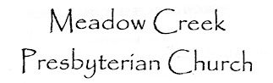
Glorifying God and Enjoying Him Forever

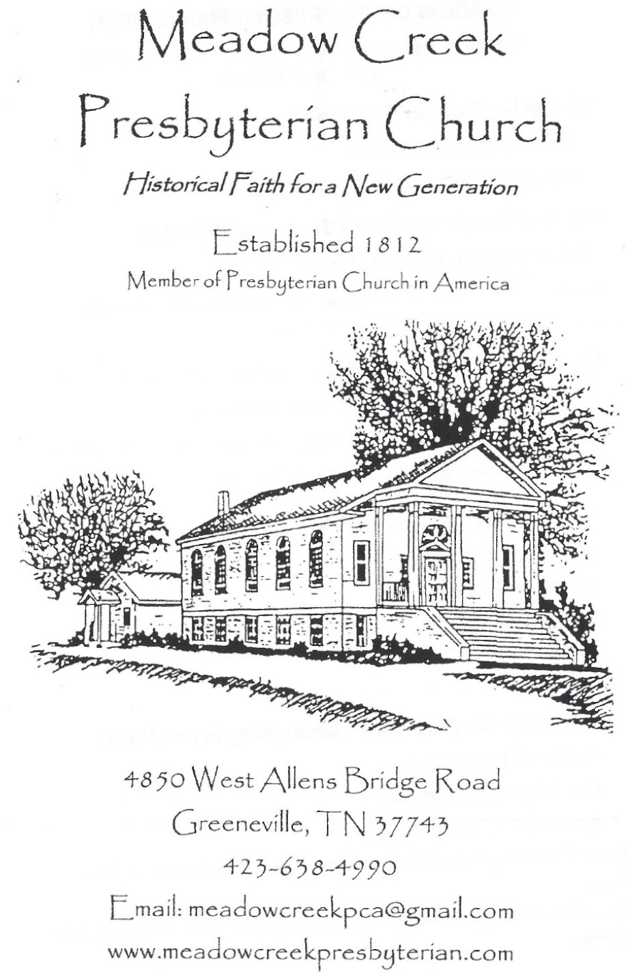

Lord’s Day Service of Worship

April 26, 2026

Established 1812

Member of the Presbyterian Church in America

